Dashboard
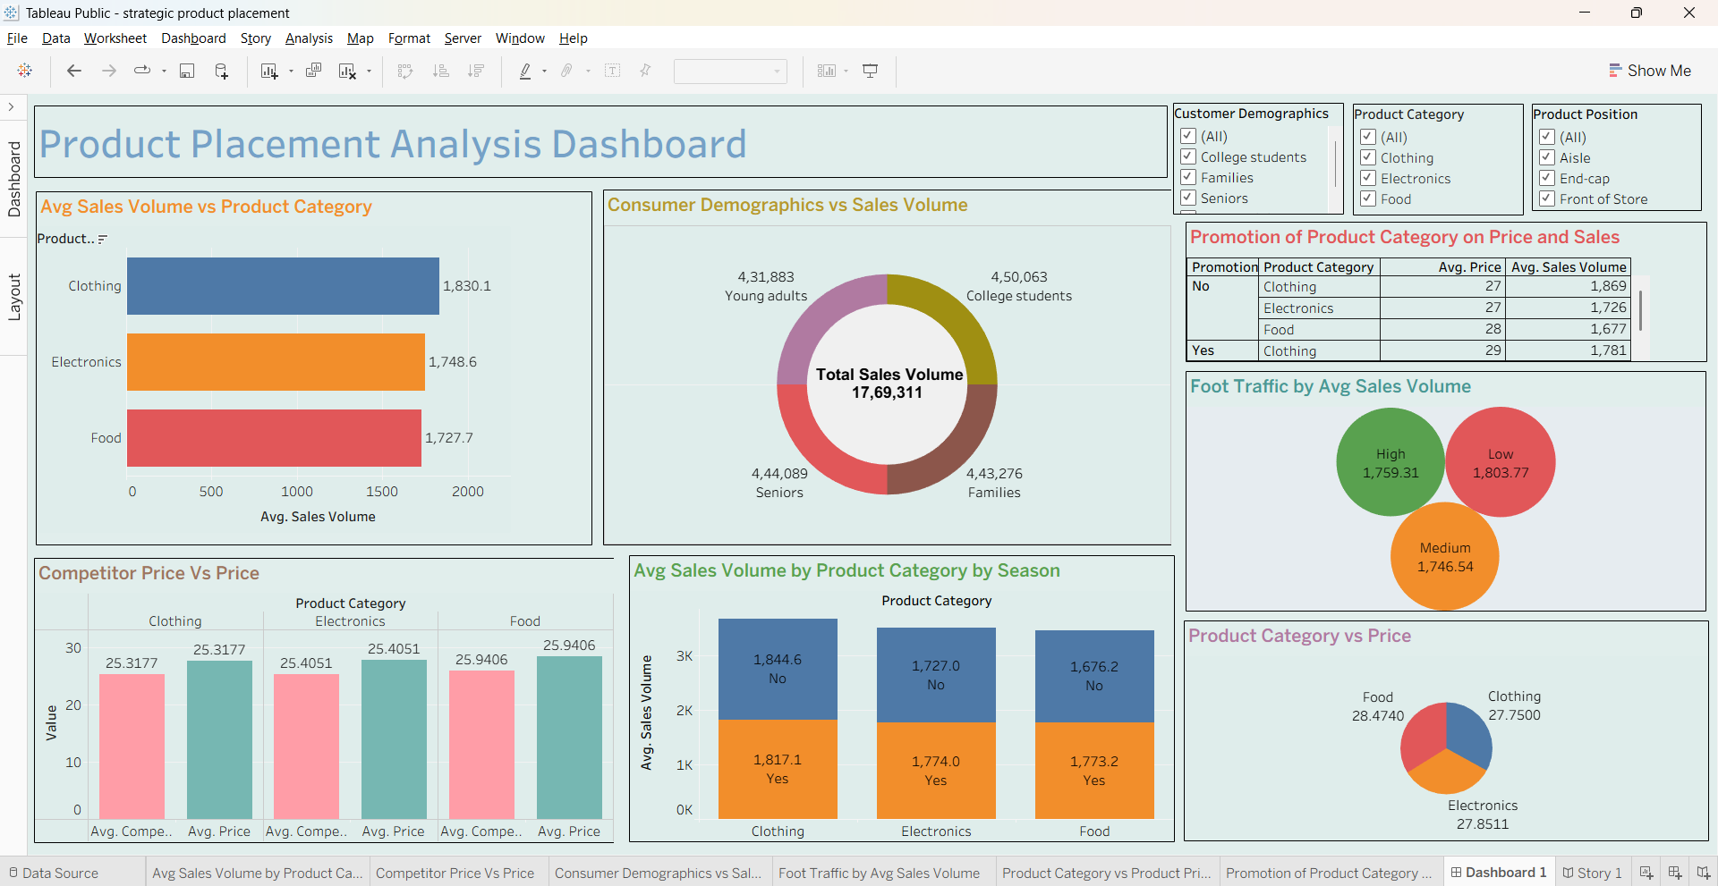

Story
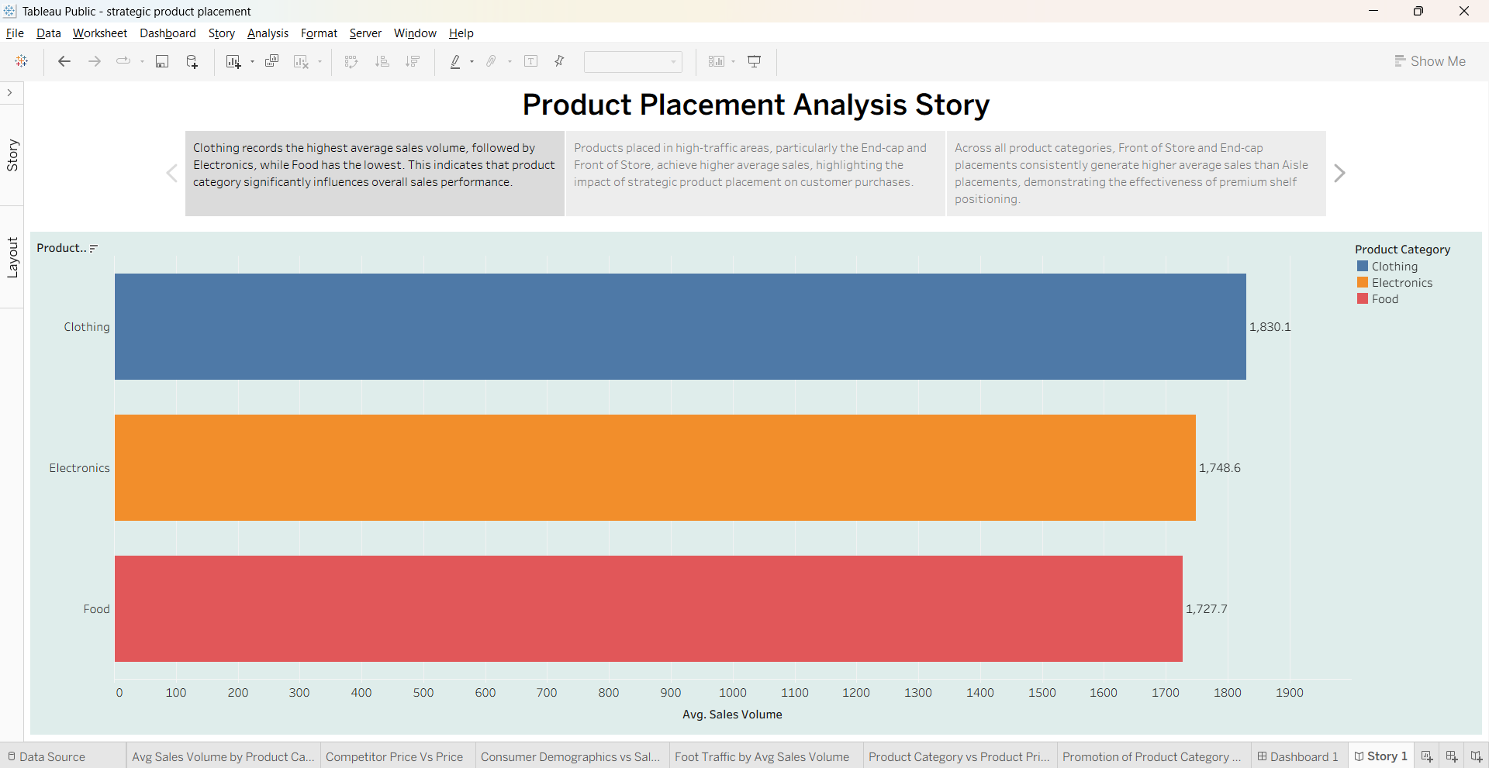

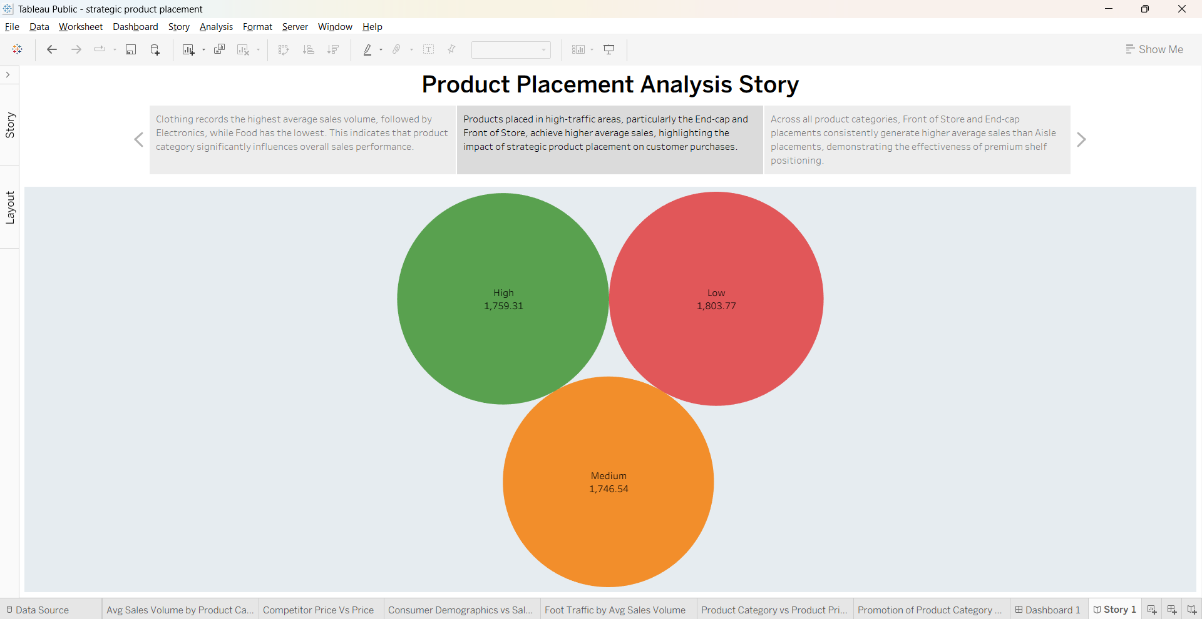
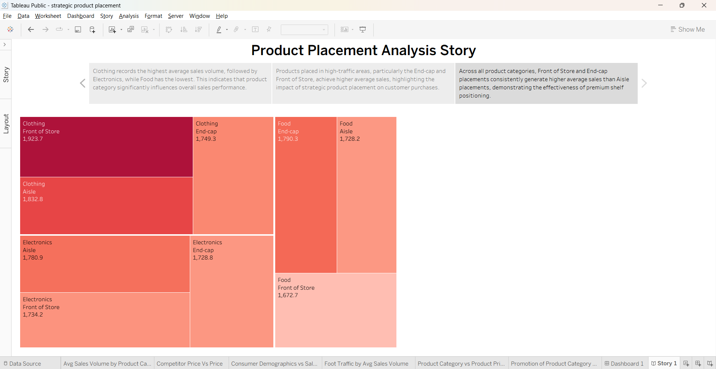

Tableau Public Links :
https://public.tableau.com/views/strategicproductplacement_17827584844880/Dashboard1?:language=en-US&publish=yes&:sid=&:redirect=auth&:display_count=n&:origin=viz_share_link
https://public.tableau.com/views/strategicproductplacement_17827584844880/Story1?:language=en-US&publish=yes&:sid=&:redirect=auth&:display_count=n&:origin=viz_share_link

